DBMS LAB EXPERIMENTS — ZOO DATABASE
NITTHYENDREN JS 192421180
QUESTION 1
AIM:
To create a table named `ANIMAL` with columns `AnimalID`, `AnimalName`, `Gender`, `DOB`, `City`, and `Age` using DDL statement.
PROCEDURE:
1. Open the SQL database terminal/client.
2. Execute the `CREATE TABLE` command specifying table name `Animal` and defined data types for each attribute.
3. Verify the creation using `DESC Animal;`.
CODE / SQL QUERY:
CREATE TABLE Animal (
AnimalID INT,
AnimalName VARCHAR(30),
Gender CHAR(1),
DOB DATE,
City VARCHAR(20),
Age INT
);

Output:
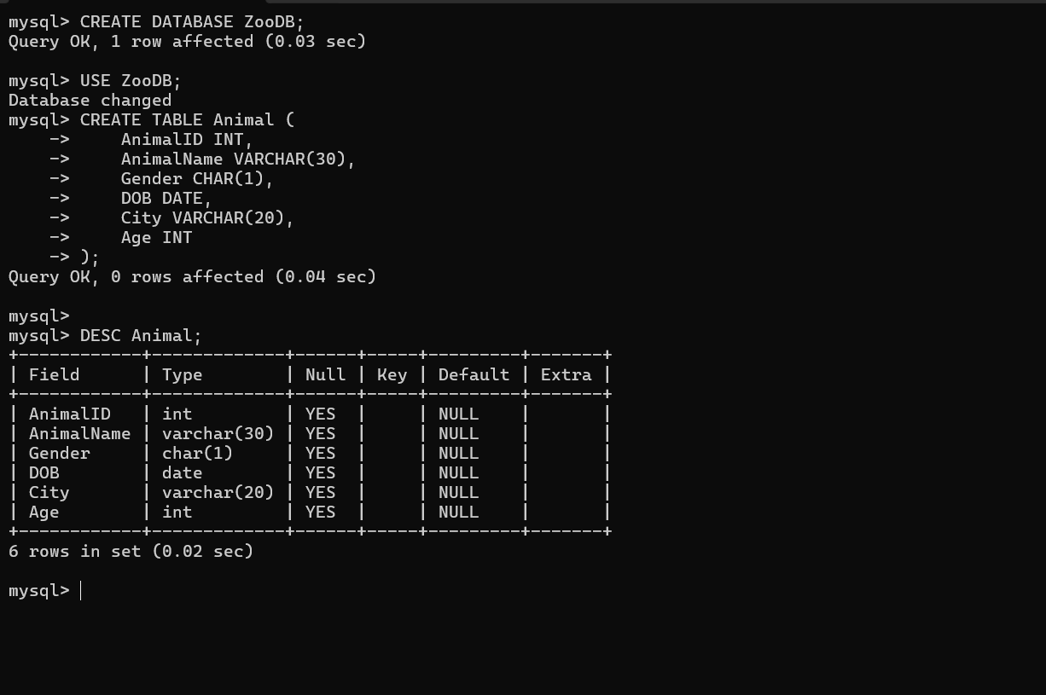
Result
The `ANIMAL` table has been created successfully with the required columns and data types.

QUESTION 2
AIM:
To create a table named `KEEPER` with columns `KeeperID`, `KeeperName`, `Gender`, `DOB`, `DOJ`, `MobileNo`, `Age`, and `DepartmentID` using DDL statement.
PROCEDURE:
1. Open the SQL database terminal/client.
2. Execute the `CREATE TABLE` command specifying table name `Keeper` and defined data types for each attribute.
3. Verify the creation using `DESC Keeper;`.
CODE / SQL QUERY:
CREATE TABLE Keeper (
KeeperID VARCHAR(5),
KeeperName VARCHAR(30),
Gender CHAR(1),
DOB DATE,
DOJ DATE,
MobileNo VARCHAR(15),
Age INT,
DepartmentID VARCHAR(5)
);

Output:
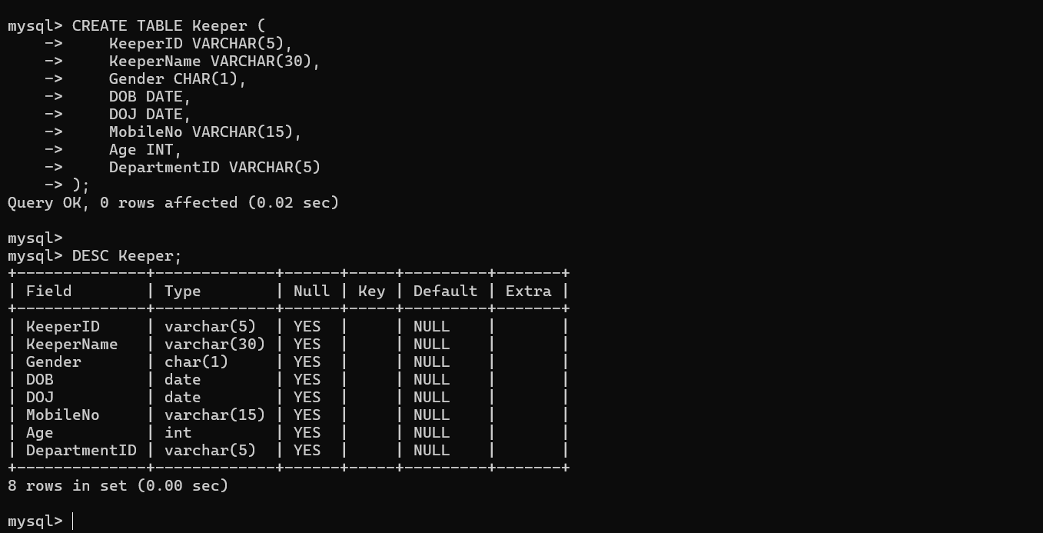Result
The `KEEPER` table has been created successfully with the required columns and data types.

QUESTION 3
AIM:
To create a table named `DEPARTMENT` with columns `DeptID`, `DeptName`, and `DeptHead` using DDL statement.
PROCEDURE:
1. Open the SQL database terminal/client.
2. Execute the `CREATE TABLE` command specifying table name `Department` and defined data types for each attribute.
3. Verify the creation using `DESC Department;`.
CODE / SQL QUERY:
CREATE TABLE Department (
DeptID VARCHAR(5),
DeptName VARCHAR(30),
DeptHead VARCHAR(5)
);

Output:
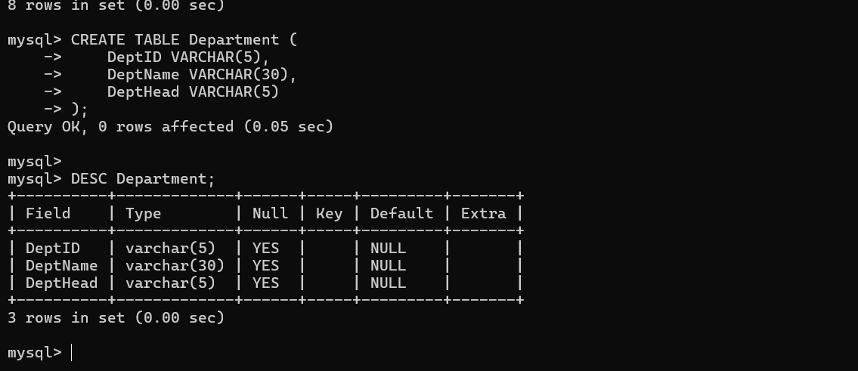Result
The `DEPARTMENT` table has been created successfully with the required columns and data types.

QUESTION 4
AIM:
To create a table named `ACTIVITY` with columns `ActivityID`, `ActivityName`, `ActivityType`, `LevelNo`, `EnclosureNo`, and `KeeperID` using DDL statement.
PROCEDURE:
1. Open the SQL database terminal/client.
2. Execute the `CREATE TABLE` command specifying table name `Activity` and defined data types for each attribute.
3. Verify the creation using `DESC Activity;`.
CODE / SQL QUERY:
CREATE TABLE Activity (
ActivityID VARCHAR(5),
ActivityName VARCHAR(30),
ActivityType CHAR(1),
LevelNo INT,
EnclosureNo VARCHAR(5),
KeeperID VARCHAR(5)
);

Output:
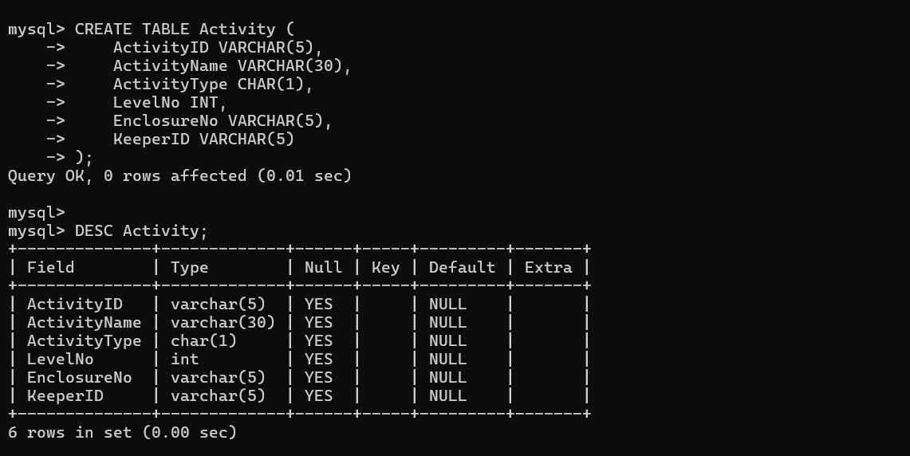Result
The `ACTIVITY` table has been created successfully with the required columns and data types.

QUESTION 5
AIM:
To modify the table `KEEPER` by adding a new column `Specialization` of datatype `VARCHAR(30)` using the DDL `ALTER` statement.
PROCEDURE:
1. Open the SQL database terminal/client.
2. Execute the `ALTER TABLE` command with the `ADD` clause to insert the new column `Specialization` into the `Keeper` table.
3. Verify the modification using `DESC Keeper;`.
CODE / SQL QUERY:
ALTER TABLE Keeper
ADD Specialization VARCHAR(30);

Output:
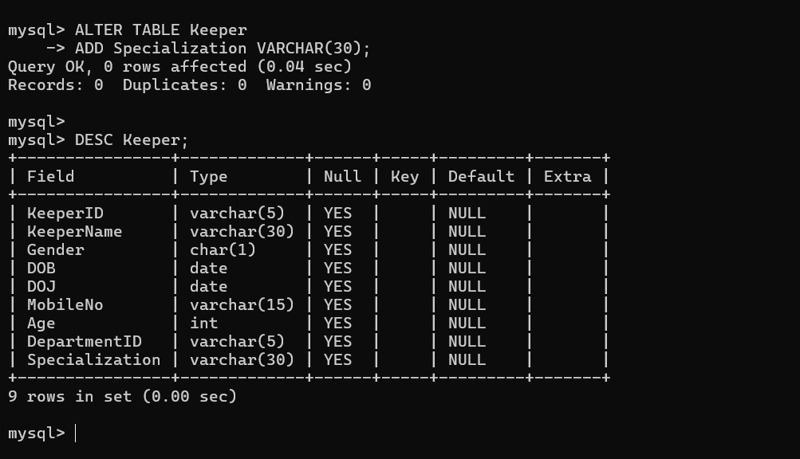Result
The column `Specialization` has been added successfully to the `KEEPER` table.

QUESTION 6
AIM:
To alter the table `ANIMAL` by adding a `PRIMARY KEY` constraint on the column `AnimalID` using DDL statement.
PROCEDURE:
1. Execute the `ALTER TABLE` command with the `ADD PRIMARY KEY` clause on `AnimalID`.
2. Verify the constraint using `DESC Animal;`.
CODE / SQL QUERY:
ALTER TABLE Animal
ADD PRIMARY KEY (AnimalID);

Output:
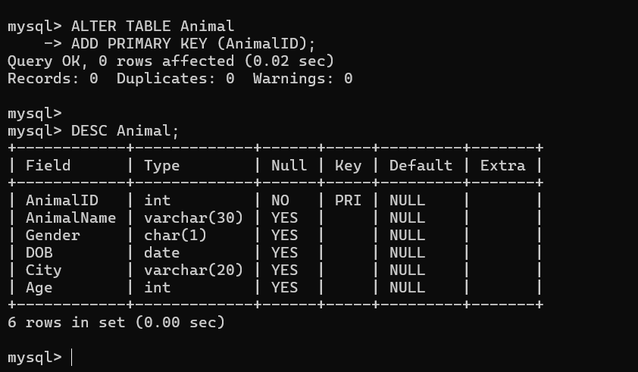Result
The `PRIMARY KEY` constraint has been added successfully to the `AnimalID` column of `ANIMAL`.

QUESTION 7
AIM:
To alter the table `KEEPER` by adding a `PRIMARY KEY` constraint on `KeeperID` and a `CHECK` constraint on `Gender` to allow only `'M'` or `'F'`.
PROCEDURE:
1. Execute the `ALTER TABLE` command with the `ADD PRIMARY KEY` clause on `KeeperID`.
2. Execute the `ALTER TABLE` command with the `ADD CONSTRAINT ... CHECK` clause on `Gender`.
3. Verify both constraints using `DESC Keeper;`.
CODE / SQL QUERY:
ALTER TABLE Keeper
ADD PRIMARY KEY (KeeperID);

ALTER TABLE Keeper
ADD CONSTRAINT chk_gender
CHECK (Gender IN ('M','F'));

Output:
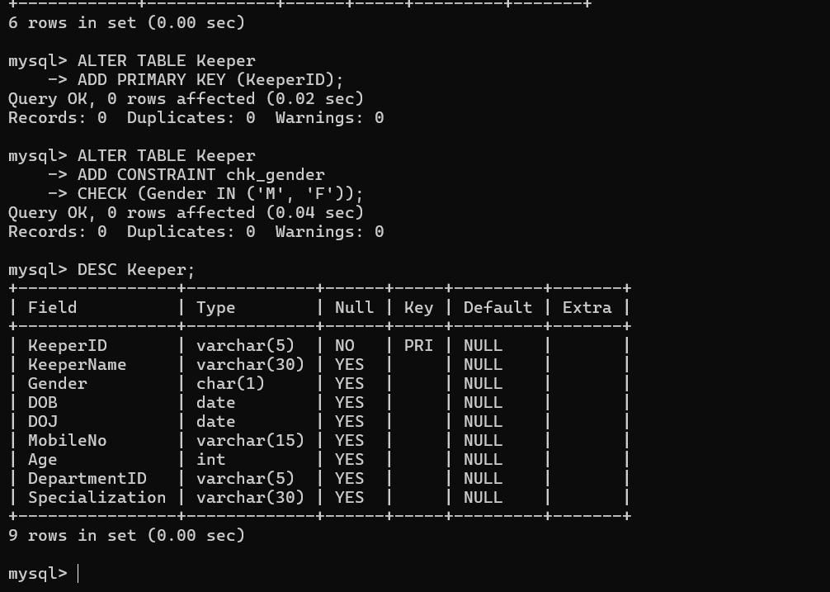Result
The `PRIMARY KEY` and `CHECK` constraints have been added successfully to the `KEEPER` table.

QUESTION 8
AIM:
To alter the table `DEPARTMENT` by adding a `PRIMARY KEY` constraint on the column `DeptID` using DDL statement.
PROCEDURE:
1. Execute the `ALTER TABLE` command with the `ADD PRIMARY KEY` clause on `DeptID`.
2. Verify the constraint using `DESC Department;`.
CODE / SQL QUERY:
ALTER TABLE Department
ADD PRIMARY KEY (DeptID);

Output:
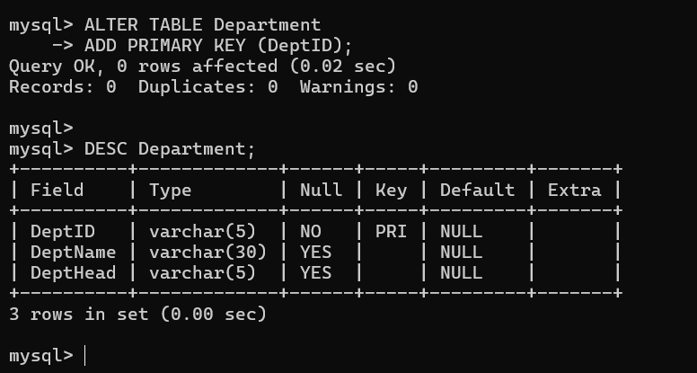Result
The `PRIMARY KEY` constraint has been added successfully to the `DeptID` column of `DEPARTMENT`.

QUESTION 9
AIM:
To alter the table `ACTIVITY` by adding a `PRIMARY KEY` constraint on `ActivityID` and a `CHECK` constraint restricting `LevelNo` to values between 1 and 6.
PROCEDURE:
1. Execute the `ALTER TABLE` command with the `ADD PRIMARY KEY` clause on `ActivityID`.
2. Execute the `ALTER TABLE` command with the `ADD CONSTRAINT ... CHECK` clause on `LevelNo`.
3. Verify both constraints using `DESC Activity;`.
CODE / SQL QUERY:
ALTER TABLE Activity
ADD PRIMARY KEY (ActivityID);

ALTER TABLE Activity
ADD CONSTRAINT chk_level
CHECK (LevelNo BETWEEN 1 AND 6);

Output:
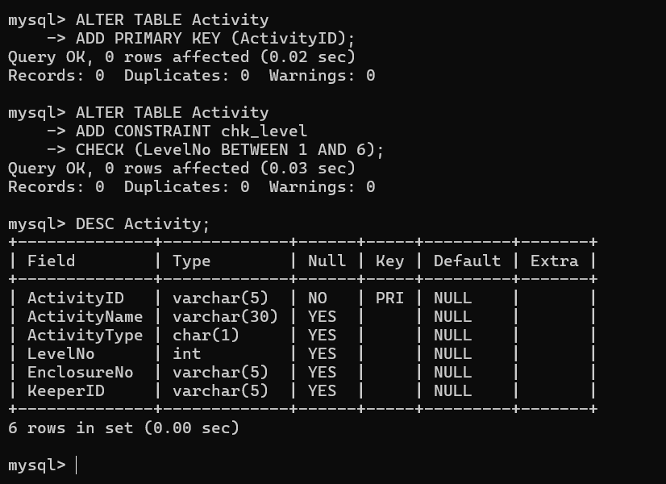Result
The `PRIMARY KEY` and `CHECK` constraints have been added successfully to the `ACTIVITY` table.

QUESTION 10
AIM:
To alter the table `ANIMAL` by adding a `UNIQUE` constraint on the column `AnimalName` using DDL statement.
PROCEDURE:
1. Execute the `ALTER TABLE` command with the `ADD CONSTRAINT ... UNIQUE` clause on `AnimalName`.
2. Verify the constraint using `DESC Animal;`.
CODE / SQL QUERY:
ALTER TABLE Animal
ADD CONSTRAINT unique_animal_name
UNIQUE (AnimalName);

Output:
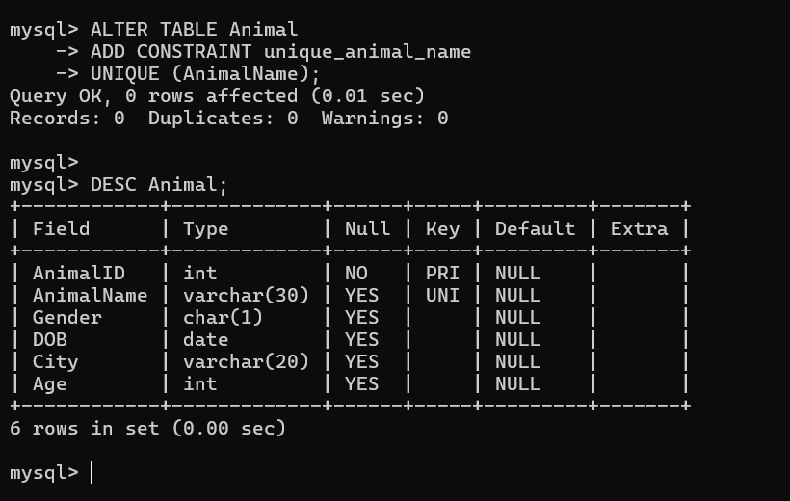Result
The `UNIQUE` constraint has been added successfully to the `AnimalName` column of `ANIMAL`.

QUESTION 11
AIM:
To create the table `ANIMAL_ACTIVITY` and test adding `FOREIGN KEY` constraints referencing the `ANIMAL` and `ACTIVITY` tables.
PROCEDURE:
1. Execute the `CREATE TABLE` command to create `Animal_Activity` with columns `AnimalID`, `ActivityID`, `Score`, and `AssessmentNo`.
2. Execute the `ALTER TABLE` command with `ADD CONSTRAINT ... FOREIGN KEY` referencing `Animal(AnimalID)`.
3. Execute the `ALTER TABLE` command with `ADD CONSTRAINT ... FOREIGN KEY` referencing `Activity(ActivityID)`.
4. Verify both constraints using `DESC Animal_Activity;`.
CODE / SQL QUERY:
CREATE TABLE Animal_Activity (
AnimalID INT,
ActivityID VARCHAR(5),
Score INT,
AssessmentNo INT
);

ALTER TABLE Animal_Activity
ADD CONSTRAINT fk_animal
FOREIGN KEY (AnimalID)
REFERENCES Animal(AnimalID);

ALTER TABLE Animal_Activity
ADD CONSTRAINT fk_activity
FOREIGN KEY (ActivityID)
REFERENCES Activity(ActivityID);

Output:
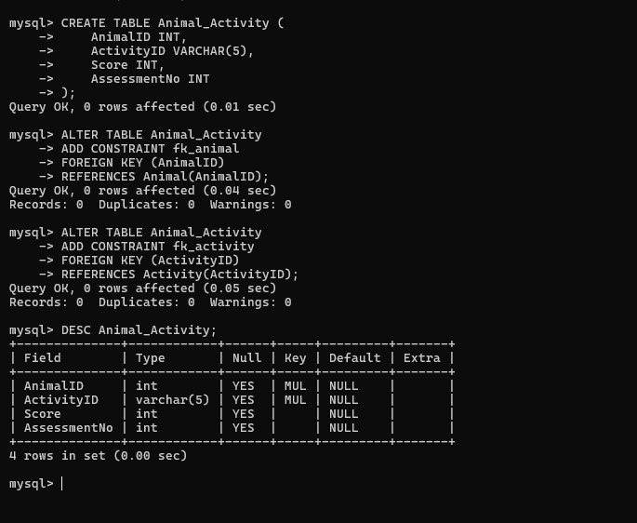Result
The `FOREIGN KEY` constraints were added successfully, linking `ANIMAL_ACTIVITY` to the `ANIMAL` and `ACTIVITY` tables.

QUESTION 12
AIM:
To populate the `ANIMAL`, `DEPARTMENT`, `KEEPER`, `ACTIVITY`, and `ANIMAL_ACTIVITY` tables with sample data using the `INSERT INTO` statement.
PROCEDURE:
1. Execute the `INSERT INTO` command for each table, supplying values for every column.
2. Repeat the `INSERT` statement for multiple rows in each table.
3. Verify the insertion using a `SELECT` statement on each table.
CODE / SQL QUERY:
INSERT INTO Animal VALUES
(101, 'Sheru', 'M', '2018-05-10', 'Chennai', 8),
(102, 'Maya', 'F', '2020-03-15', 'Salem', 6),
(103, 'Ramesh', 'M', '2017-07-20', 'Madurai', 9),
(104, 'Lakshmi', 'F', '2021-01-12', 'Salem', 5),
(105, 'Krish', 'M', '2019-11-25', 'Chennai', 7),
(106, 'Ash', 'M', '2016-09-18', 'Coimbatore', 10),
(107, 'Amara', 'F', '2022-04-10', 'Salem', 4);

INSERT INTO Department VALUES
('D01', 'Mammals', 'K01'),
('D02', 'Birds', 'K02'),
('D03', 'Reptiles', 'K03'),
('D04', 'Aquatic', 'K04');

INSERT INTO Keeper
(KeeperID, KeeperName, Gender, DOB, DOJ, MobileNo, Age, DepartmentID, Specialization)
VALUES
('K01', 'Mohan', 'M', '1967-04-10', '2010-06-15', '9876543210', 59, 'D01', 'Mammals'),
('K02', 'Kamal', 'M', '1980-08-20', '2012-05-10', '9876543211', 46, 'D02', 'Birds'),
('K03', 'Ratnam', 'F', '1975-02-15', '2013-03-12', '9876543212', 51, 'D03', 'Reptiles'),
('K04', 'Priya', 'F', '1990-11-25', '2016-07-20', '9876543213', 36, 'D04', 'Aquatic'),
('K05', 'Arun', 'M', '1955-05-15', '2008-01-10', '9876543214', 71, 'D01', 'Mammals');

INSERT INTO Activity VALUES
('A01', 'Statistics', 'A', 1, 'H001', 'K01'),
('A02', 'Programming', 'B', 2, 'H002', 'K02'),
('A03', 'Feeding', 'C', 3, 'H003', 'K03'),
('A04', 'Training', 'D', 4, 'H004', 'K04'),
('A05', 'Health Check', 'E', 5, 'H002', 'K01');

INSERT INTO Animal_Activity VALUES
(101, 'A01', 75, 1),
(101, 'A02', 85, 2),
(102, 'A01', 65, 1),
(102, 'A03', 55, 2),
(103, 'A01', 90, 1),
(103, 'A02', 70, 2),
(104, 'A02', 45, 1),
(105, 'A03', 80, 1),
(105, 'A04', 88, 2),
(106, 'A01', 50, 1),
(107, 'A04', 95, 1);

Output:
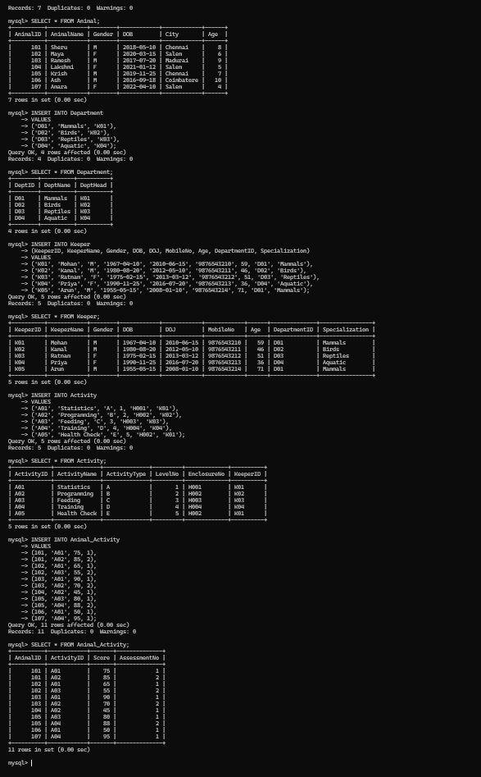Result
Sample records have been inserted successfully into all five tables.

QUESTION 13
AIM:
To view all the records from the `ANIMAL`, `KEEPER`, `DEPARTMENT`, `ACTIVITY`, and `ANIMAL_ACTIVITY` tables using the `SELECT` statement.
PROCEDURE:
1. Execute the `SELECT * FROM` command for each table.
2. Observe the returned result set for every table.
CODE / SQL QUERY:
SELECT * FROM Animal;
SELECT * FROM Keeper;
SELECT * FROM Department;
SELECT * FROM Activity;
SELECT * FROM Animal_Activity;

Output:
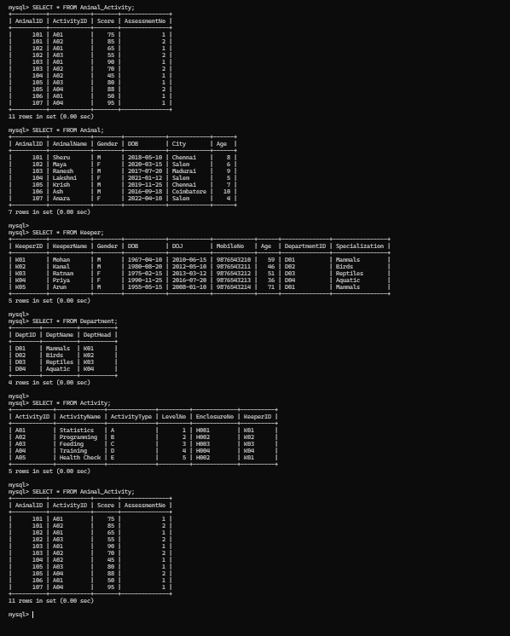Result
All the records from the five tables were displayed successfully.

QUESTION 14
AIM:
To update the value of the animal name whose `AnimalID` is `101` using the `UPDATE` statement.
PROCEDURE:
1. Execute the `UPDATE` command specifying the `Animal` table and the `SET` clause with the new name.
2. Restrict the update using the `WHERE` clause on `AnimalID`.
3. Verify the change using a `SELECT` statement.
CODE / SQL QUERY:
UPDATE Animal
SET AnimalName = 'Simba'
WHERE AnimalID = 101;

Output:
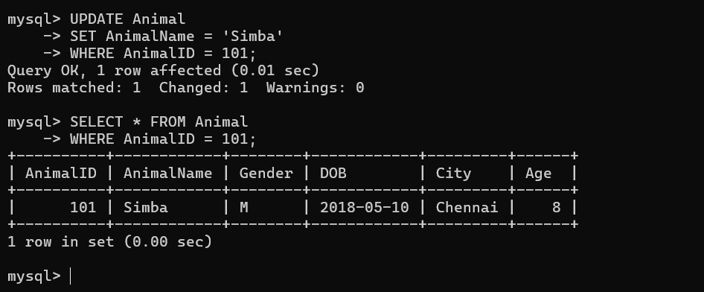Result
The animal name has been updated successfully for the given `AnimalID`.

QUESTION 15
AIM:
To delete the record of the keeper (`KeeperID` `'K04'`) who has resigned from the job, using the `DELETE` statement.
PROCEDURE:
1. Identify the record of the resigned keeper.
2. Execute the `DELETE FROM` command with a `WHERE` clause identifying that keeper.
3. Verify the deletion using a `SELECT` statement.
CODE / SQL QUERY:
DELETE FROM Keeper
WHERE KeeperID = 'K04';

Output:
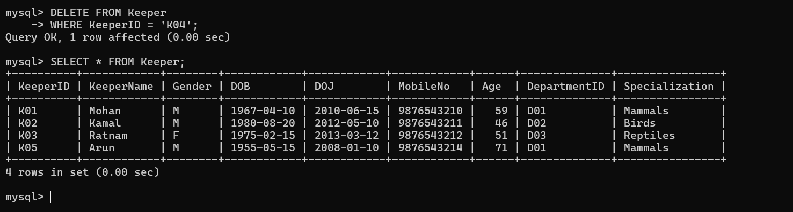Result
The record of the resigned keeper has been deleted successfully.

QUESTION 16
AIM:
To modify the age of the keeper named `'Mohan'` to the value `'59'` using the `UPDATE` statement.
PROCEDURE:
1. Execute the `UPDATE` command specifying the `Keeper` table and the `SET` clause with the new age value.
2. Restrict the update using the `WHERE` clause on `KeeperName`.
3. Verify the change using a `SELECT` statement.
CODE / SQL QUERY:
UPDATE Keeper
SET Age = 59
WHERE KeeperName = 'Mohan';

Output:
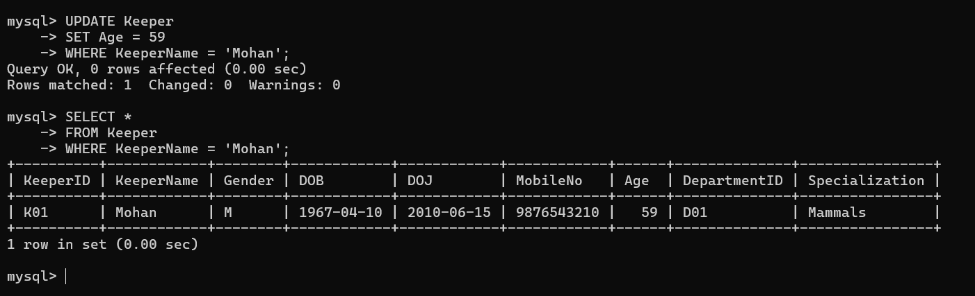Result
The age value has been updated successfully for the keeper `'Mohan'`.

QUESTION 17
AIM:
To remove all keeper records for keepers who are over 65 years of age, using the `DELETE` statement.
PROCEDURE:
1. Execute the `DELETE FROM` command specifying the `Keeper` table.
2. Restrict the deletion using the `WHERE` clause on the `Age` column.
3. Verify the deletion using a `SELECT` statement.
CODE / SQL QUERY:
DELETE FROM Keeper
WHERE Age > 65;

Output:
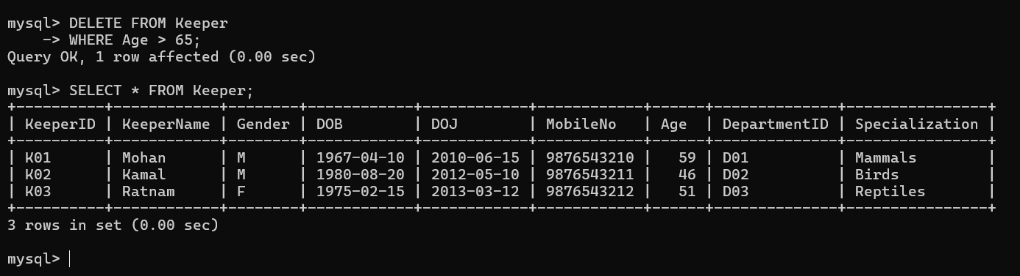Result
All keeper records with age over 65 years have been removed successfully.

QUESTION 18
AIM:
To display the `AnimalID`, `AnimalName`, and date of birth for all the animals using the `SELECT` statement.
PROCEDURE:
1. Execute the `SELECT` command specifying the required columns `AnimalID`, `AnimalName`, and `DOB`.
2. Specify the `Animal` table in the `FROM` clause.
3. Observe the returned result set.
CODE / SQL QUERY:
SELECT AnimalID, AnimalName, DOB
FROM Animal;

Output:
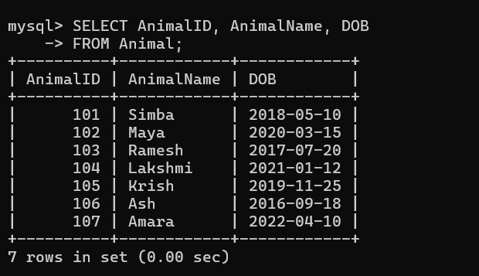
Result
The `AnimalID`, name, and date of birth of all animals were displayed successfully.

QUESTION 19
AIM:
To list all the female animals using the `SELECT` statement with the `WHERE` clause.
PROCEDURE:
1. Execute the `SELECT` command specifying the `Animal` table.
2. Apply the `WHERE` clause to filter records where `Gender = 'F'`.
3. Observe the returned result set.
CODE / SQL QUERY:
SELECT *
FROM Animal
WHERE Gender = 'F';

Output:
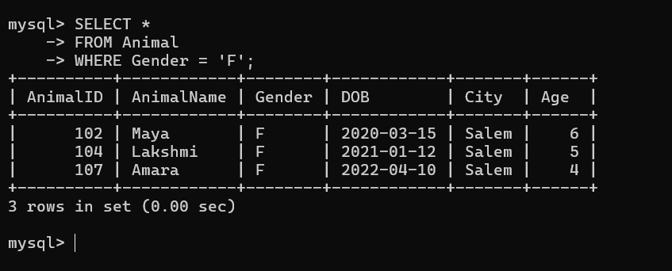Result
All the female animals were listed successfully.

QUESTION 20
AIM:
To list the animals registered for the activity `'A01'` using the `SELECT` statement with a `JOIN` and the `WHERE` clause.
PROCEDURE:
1. Join the `Animal` table with the `Animal_Activity` table on `AnimalID`.
2. Apply the `WHERE` clause to filter records where `ActivityID = 'A01'`.
3. Observe the returned result set.
CODE / SQL QUERY:
SELECT Animal.AnimalID, Animal.AnimalName, Animal_Activity.ActivityID
FROM Animal
JOIN Animal_Activity
ON Animal.AnimalID = Animal_Activity.AnimalID
WHERE Animal_Activity.ActivityID = 'A01';

Output:
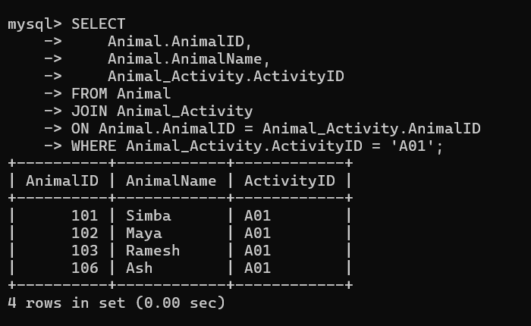Result
The animals registered for the activity `'A01'` were listed successfully.

QUESTION 21
AIM:
To display all keeper details who joined before November 2014 using the `SELECT` statement with the `WHERE` clause on `DOJ`.
PROCEDURE:
1. Execute the `SELECT` command specifying the `Keeper` table.
2. Apply the `WHERE` clause to filter records where `DOJ` is earlier than `'2014-11-01'`.
3. Observe the returned result set.
CODE / SQL QUERY:
SELECT *
FROM Keeper
WHERE DOJ < '2014-11-01';

Output:
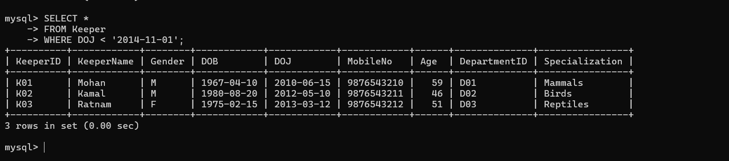Result
All keepers who joined before November 2014 were displayed successfully.

